Contents
Overview: Navigation in SAP 2
Business Process Procedure: Navigation in SAP. 2
SAP Logon 2
Session Manger 5
SAP Menu 6
Transaction Code 7
Standard Toolbar 7
SAP Easy Access Settings 8
User Settings 9
Messages in SAP 11
Required Fields 11
SAP F4 Help 11

OVERVIEW

Business Process Description Overview

Overview: Navigation in SAP
Navigation in SAP involves the following:

- Logging into SAP.
- Understanding SAP screen layout.
- Exploring SAP and User Menu.
- Transaction Codes and executing Transactions.
- SAP Toolbars.
- User specific settings.
- Messaging
- SAP Messages.
- SAP Help.

Business Process Procedure: Navigation in SAP.

SAP Logon
Procedure
To logon to SAP, start the SAP Logon Pad by double clicking on the SAP Logon icon appearing in the desktop.
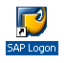
The SAP Logon Pad will appear. Select the server and click on “Log On”. The SAP Login screen will appear after this.

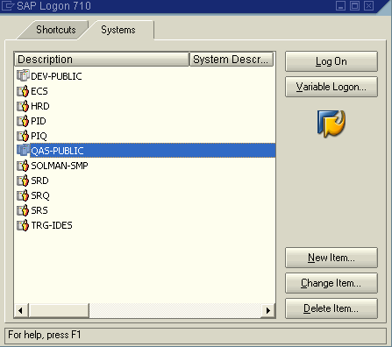

In the SAP Login screen, type the User ID and Password. User ID is not case sensitive but password is case sensitive. The password field is masked, i.e., “*” cannot be deleted. After entering the User ID and Password, click on the icon highlighted or press enter.
It is to be remembered that if incorrect password is entered thrice, the User Account gets locked and the System Administrator needs to be contacted for unlocking the account.

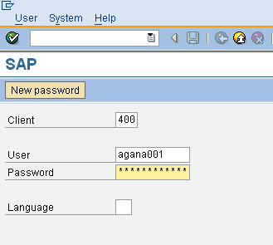
After successful login, the first screen to be displayed is called the “Session Manager”.

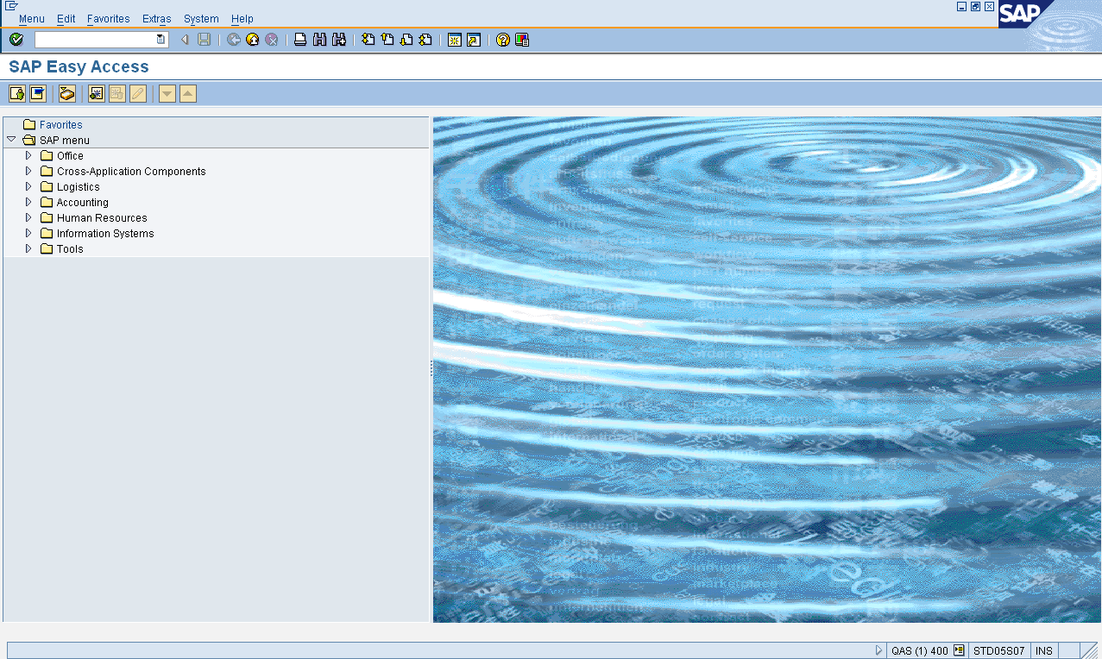

Session Manger

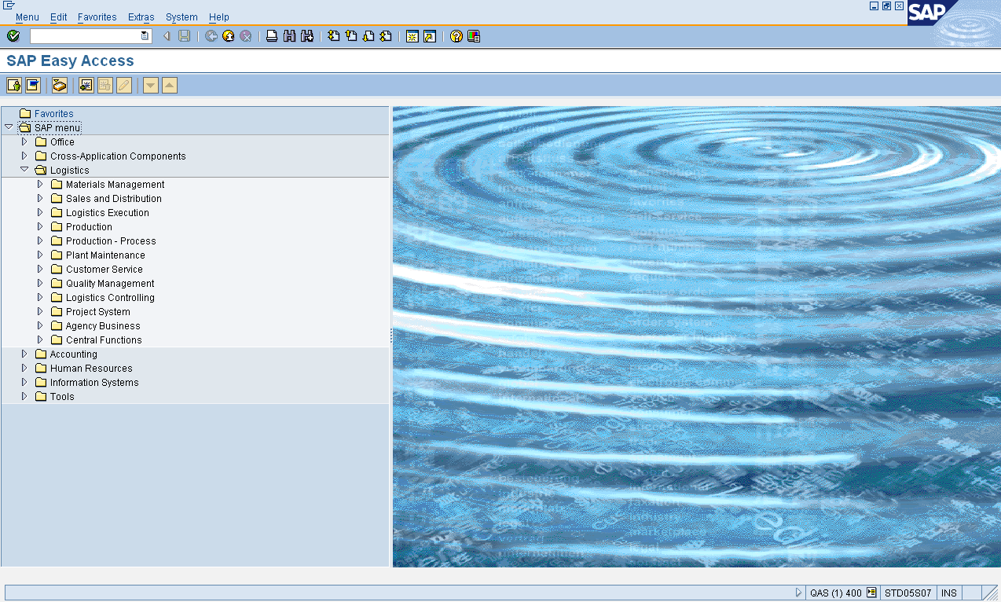
Menu Bar
Standard Tool Bar
Title Bar
Application Tool Bar
Status Bar
Server ID
SAP System ID

SAP Menu

SAP Menu is used to group all Transaction Codes / Applications. The SAP Menu can be expanded and collapse menus in the navigation area by choosing the dropdown arrows to the left of the menu items. To open an application in the navigation area, Double-Click the node.

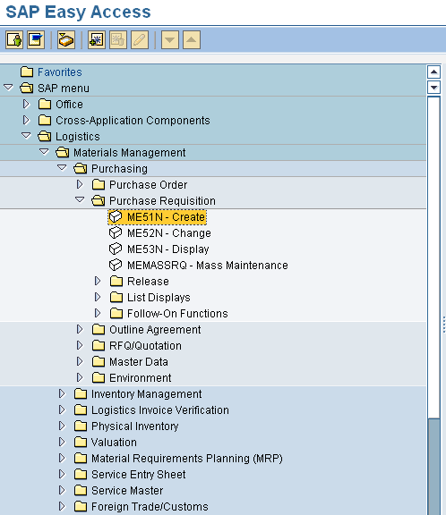

Transaction Code
A Transaction Code can be started in four different ways –
- Position the cursor on the Transaction in the SAP Menu and press Enter.
- Double click on the required Transaction in the SAP Menu.
- Position the cursor on the required Transaction in SAP Menu and select Edit → Execute (or press F2).
- Expand the Command Field and enter the Transaction Code.

A Transaction Code can be entered in the Command Field.
If the Transaction is preceded by a “/N”, then the transaction opens in the current session.

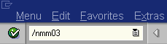

If the Transaction is preceded by a “/O”, then a new session is opened for the transaction. This means that multiple sessions are used.

Standard Toolbar
The Standard Tool Bar contains the command Field and the SAP Tool Bar.

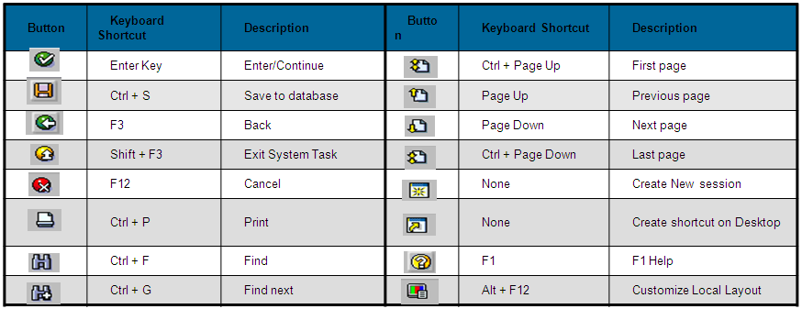

SAP Easy Access Settings

User can set how SAP displays the Menu by choosing Extras → Settings.

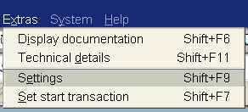

Here the following settings can be maintained:

- Position of the Favorites Menu.
- Only Favorites Menu will be displayed and SAP Menu will not be displayed.
- Picture will not be displayed in SAP Easy Access screen.
- Technical Names will be displayed in the SAP Menu.
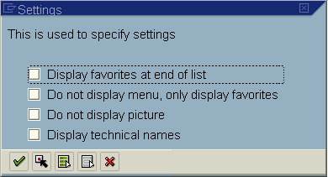

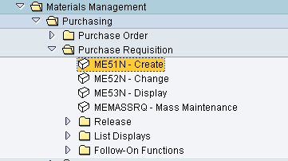

User Settings

User can maintain their own settings by choosing System → User Profile → Own Data (Defaults).

The following can be maintained –
- Default Printer.
- Language.
- Date and Decimal display formats.
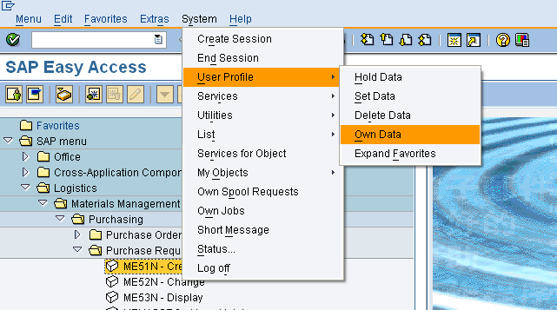

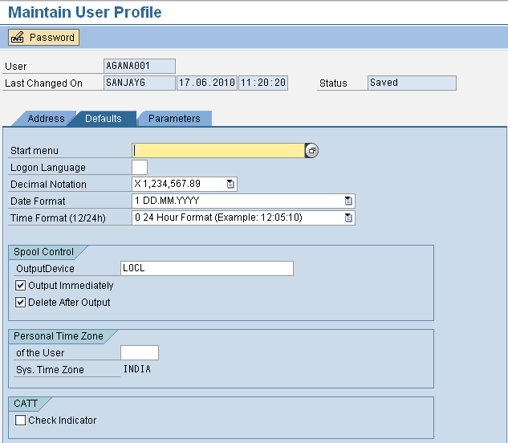

Messages in SAP

Messages appear either in the Status Bar or in a pop-up window, depending on User Settings.

Messages starting with:
- “E” indicate an Error message

- “W” indicate a Warning message

- Messages not beginning with an “E” or a “W‘’
are simply Information messages

Required Fields

Certain details or data are mandatory when processing in SAP. Such fields are called “Mandatory Fields”. Mandatory Fields are marked and can be identified easily.

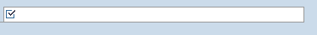

SAP F4 Help

The fields in a Transaction need to be filled with relevant data. The input of data can be of two types –

Input by User: The field is ready for input and the user can fill the data.

Selection of Data: The data to be provided needs to be selected from the available options. Data other then the options available will not be accepted by the system.

The accessing of the available data is called SAP F4 Help.

